<https://www.worldometers.info/coronavirus/>

<view-source:https://www.worldometers.info/coronavirus/>

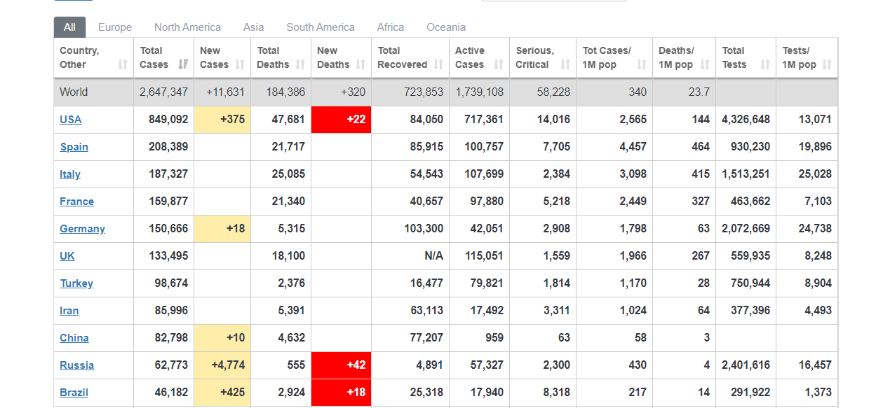

Total line

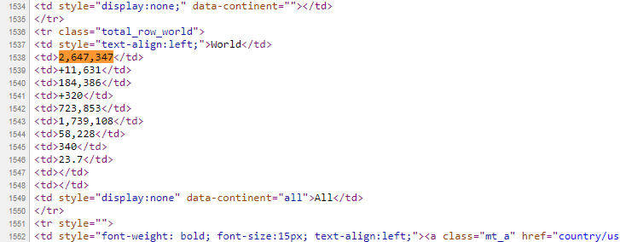

Country level info

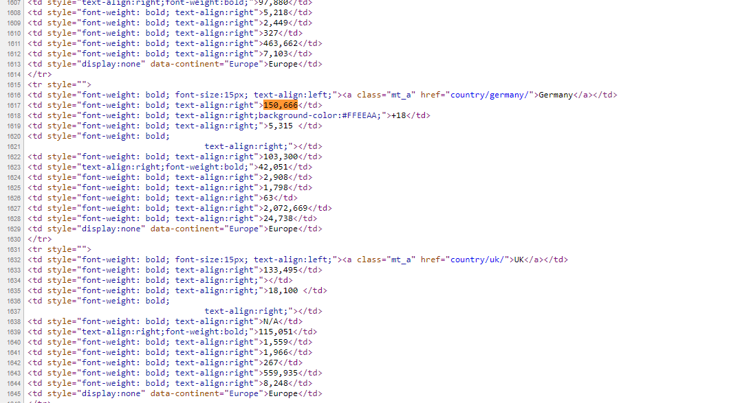

Column names

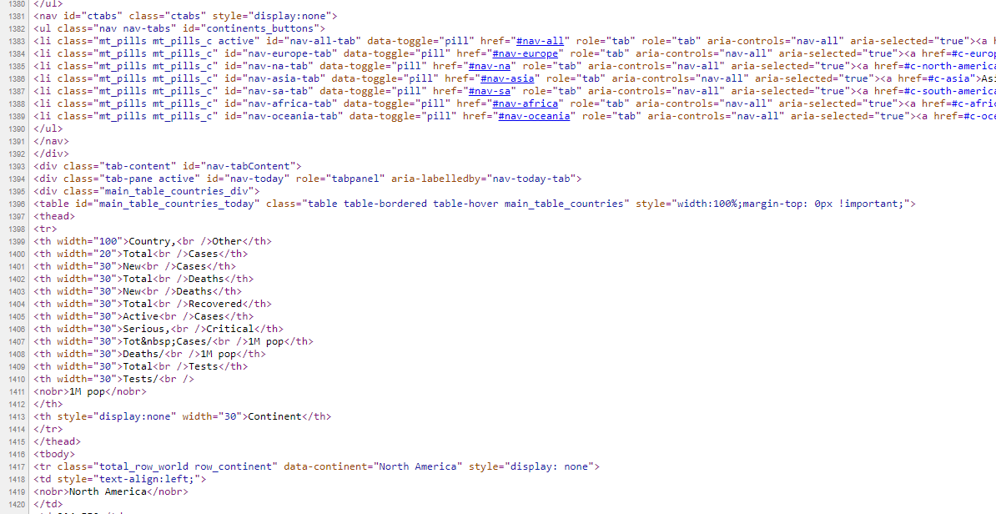

|  |
| --- |
| <div class="tab-content" id="nav-tabContent"> |
|  | <div class="tab-pane active" id="nav-today" role="tabpanel" aria-labelledby="nav-today-tab"> |
|  | <div class="main_table_countries_div"> |
|  | <table id="main_table_countries_today" class="table table-bordered table-hover main_table_countries" style="width:100%;margin-top: 0px !important;"> |
|  | <thead> |

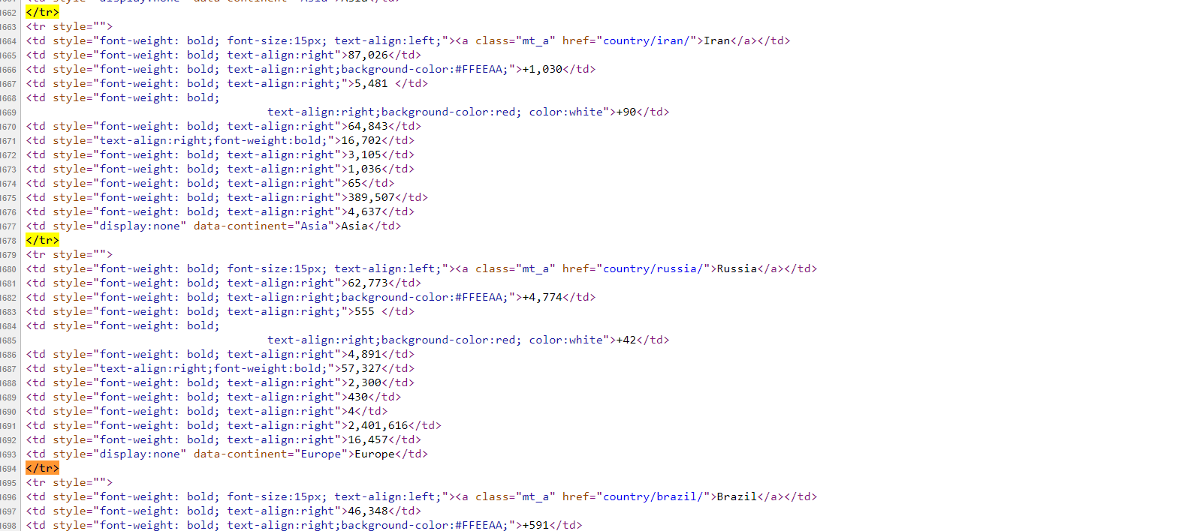

<td style="font-weight: bold; font-size:15px; text-align:left;"><a class="mt_a" href="country/peru/">Peru</a></td>

<td style="font-weight: bold; text-align:right">19,250</td>

<td style="font-weight: bold; text-align:right;"></td>

<td style="font-weight: bold; text-align:right;">530 </td>

<td style="font-weight: bold;

text-align:right;"></td>

<td style="font-weight: bold; text-align:right">7,027</td>

<td style="text-align:right;font-weight:bold;">11,693</td>

<td style="font-weight: bold; text-align:right">396</td>

<td style="font-weight: bold; text-align:right">584</td>

<td style="font-weight: bold; text-align:right">16</td>

<td style="font-weight: bold; text-align:right">170,400</td>

<td style="font-weight: bold; text-align:right">5,168</td>

<td style="display:none" data-continent="South America">South America</td>

</tr>

<tr style="">

<td style="font-weight: bold; font-size:15px; text-align:left;"><a class="mt_a" href="country/ireland/">Ireland</a></td>

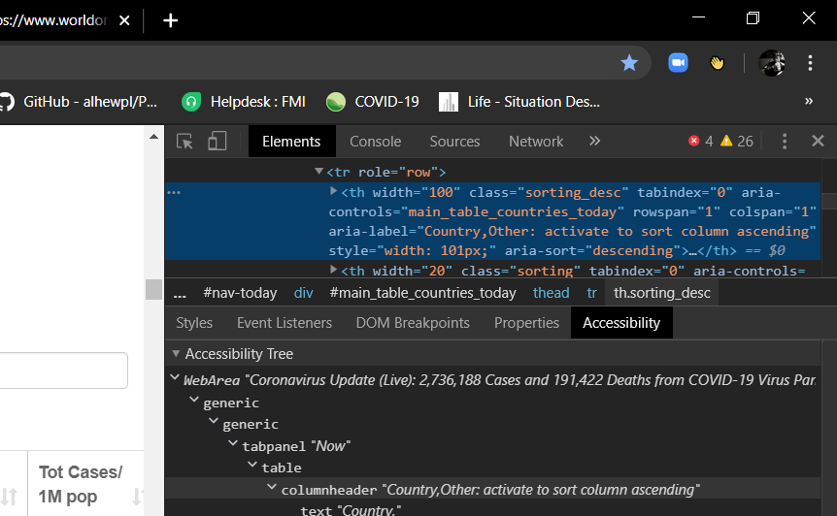

Very early versions table3

